Peer-to-Peer (P2P) Cold-Chain Freight Brokerage for Smallholder Fisheries and Horticulture in Eastern India

Project Title: HimaSetu: A P2P Passive-Cold Freight Brokerage for Smallholder Fisheries and Horticulture Farmers in Eastern India
Project Team: Aniket Maji, Debashis Malkhandy, Trinankur Sammanta, Subhajit Sarkar

Synopsis: India is the world's second-largest producer of fish (197.75 lakh tonnes) and fruits and vegetables (277 million metric tonnes), with West Bengal ranking among the leading contributors in both sectors. However, smallholder fish farmers in districts like South and North 24 Parganas and vegetable cultivators in Nadia lose 20–25% of their harvest value to thermal degradation while waiting for transport at landing centers and rural markets. Although West Bengal holds 59.5 lakh MT of cold storage capacity, over 75% of regional infrastructure is locked in stationary, single-commodity bulk potato warehouses, leaving a 99% first-mile cold-chain gap in horticulture and a 70% gap in fisheries. Smallholders harvesting 50–300 kg cannot afford full-truckload diesel reefers and rely on unrefrigerated tricycle vans (80%) or delayed shared pickups, forcing distress sales to local Aratdars and Paikars.
HimaSetu ("Cold Bridge") is a decentralized Peer-to-Peer (P2P) Cold-Chain Freight Broker that pairs an AI-driven Less-Than-Truckload (LTL) ride-sharing platform with modular Phase Change Material (PCM) eutectic insulated boxes. Accessible via vernacular voice/IVR, WhatsApp, and mobile app, the platform clusters fractional loads from neighboring farmers and matches them with local ambient vehicles (Tata Ace, e-rickshaws, boats). By placing produce inside pre-frozen PCM boxes +-1’C stability for 24+ hours), HimaSetu converts any standard village vehicle into a multi-temperature cold carrier, cutting cooling operating costs by up to 80%, eliminating waiting-time spoilage, and increasing farmer net realization by 15–25% through direct linkage to Howrah, Koley Market, and Sufal Bangla hubs.

Extended Technical Abstract (For Jury Dossier and Concept Note Upload)
Post-harvest loss across the aquatic and horticultural value chains of Eastern India (West Bengal, Bihar, and Jharkhand) is fundamentally a first-mile logistics synchronization and thermal-containment failure rather than a bulk storage deficit. Empirical assessments demonstrate that biological decay in harvested finfish, brackishwater shrimp (Penaeus monodon), and high-respiration vegetables (brinjal, bitter gourd, tomatoes, green chillies) accelerates exponentially during the 3-to-8-hour waiting window between harvest and primary dispatch. During this latency period, smallholder producers face a severe coordination asymmetry: local commercial vehicle operators refuse to dispatch 2-ton or 4-ton trucks (such as Tata Ace 107/207 or 407 models) until full payload capacity is guaranteed, while individual producers lack both the volume to charter a vehicle and the thermal packaging to preserve quality while waiting for co-loaders.
This project introduces a cyber-physical P2P Cold-Chain Freight Brokerage engineered specifically for the socio-economic and infrastructural realities of Eastern India. On the physical layer, the system replaces expensive, high-emission diesel air-blown refrigeration with Cooling-as-a-Service (CaaS) via stackable, food-grade Glass-Reinforced Plastic and Rigid Polyurethane Foam (GRP-RPUF) boxes equipped with changeable Eutectic Phase Change Material (PCM) cartridges. Tuned to specific phase-transition temperatures (0’C for aquaculture and capture fish, and +10’C for tropical vegetables), these cartridges are frozen at Women Self-Help Group (SHG) or Farmer Producer Organization (FPO) micro-hubs using grid or solar energy. On the digital layer, a spatiotemporal clustering algorithm aggregates harvest notifications submitted via vernacular IVR, USSD, or smartphone interfaces, dynamically routing nearby LTL commercial vehicles to pick up pre-chilled, IoT-monitored PCM boxes along optimized milk-run corridors. By enabling mixed-commodity co-loading on standard non-refrigerated rural vehicles, the architecture slashes transport cooling OPEX by up to 80%, disintermediates exploitative auction tiers (Aratdars and Paikars), prevents 1.5 tonnes of CO2 emissions per tonne of saved produce, and establishes a self-sustaining rural micro-entrepreneurship model aligned with Viksit Bharat and the Seva Sankalp Abhiyan.

Empirical Problem Analysis: The First-Mile Perishable Loss Crisis in Eastern India

Macro-Production Strength vs. Micro-Logistics Fragility

India stands as the second-largest fish-producing nation globally, contributing 8% to 9% of world output and achieving a record production of 197.75 lakh tonnes in FY 2024–25, up from 184.02 lakh tonnes in FY 2023–24. Inland fisheries account for approximately 70% (139.10 lakh tonnes) of total output, driven heavily by aquaculture, which holds a ~62% share with national productivity averaging 4.77 tonnes/ha. Economically, fisheries contribute 7.43% of India's Agricultural Gross Value Added (GVA)—the highest share among all agricultural and allied sub-sectors—and generate ₹62,408 crore (US$ 7.45 billion) in seafood exports. Simultaneously, India is the world's second-largest producer of fruits and vegetables at 277 million metric tonnes (MMT).
Within this national landscape, West Bengal occupies a preeminent position alongside Bihar and Jharkhand. In fisheries, West Bengal ranks among the top two fish-producing states in India, possesses the third-longest river network, and ranks third in fish seed production behind Assam and Jharkhand. The state's aquatic resource base encompasses 2.88 lakh hectares of freshwater ponds, 0.42 lakh hectares of beels and baors (oxbow lakes), 1.72 lakh hectares of rivers, 0.80 lakh hectares of canals, and 2.10 lakh hectares of brackishwater bodies (bheries), alongside 158 km of marine coastline, supporting 26.13 lakh inland fisherfolk across 6,348 villages and 3.80 lakh marine fisherfolk across 1,237 villages. In horticulture, West Bengal accounts for 7.4% of India's horticultural land area and 10% of total national horticultural output, with vegetables dominating 76% of the state's horticultural acreage.
Despite this immense primary productivity, 20% to 25% of fisheries output in India—and 20% to 60% across Asian aquatic food chains—is lost post-harvest due to thermal abuse and logistical delays, alongside massive wastage in fresh vegetables. In West Bengal's inland fish farming clusters, such as East Midnapore, North 24 Parganas, and Kharagpur, farmers spend 60% to 65% of operational costs on feed and incur unit production costs of ₹52.36 to ₹59.49 per kg in farm ponds and ₹69.59 to ₹83.82 per kg in community ponds. Consequently, a 20% post-harvest value loss erodes nearly half of the farmer's net margin.
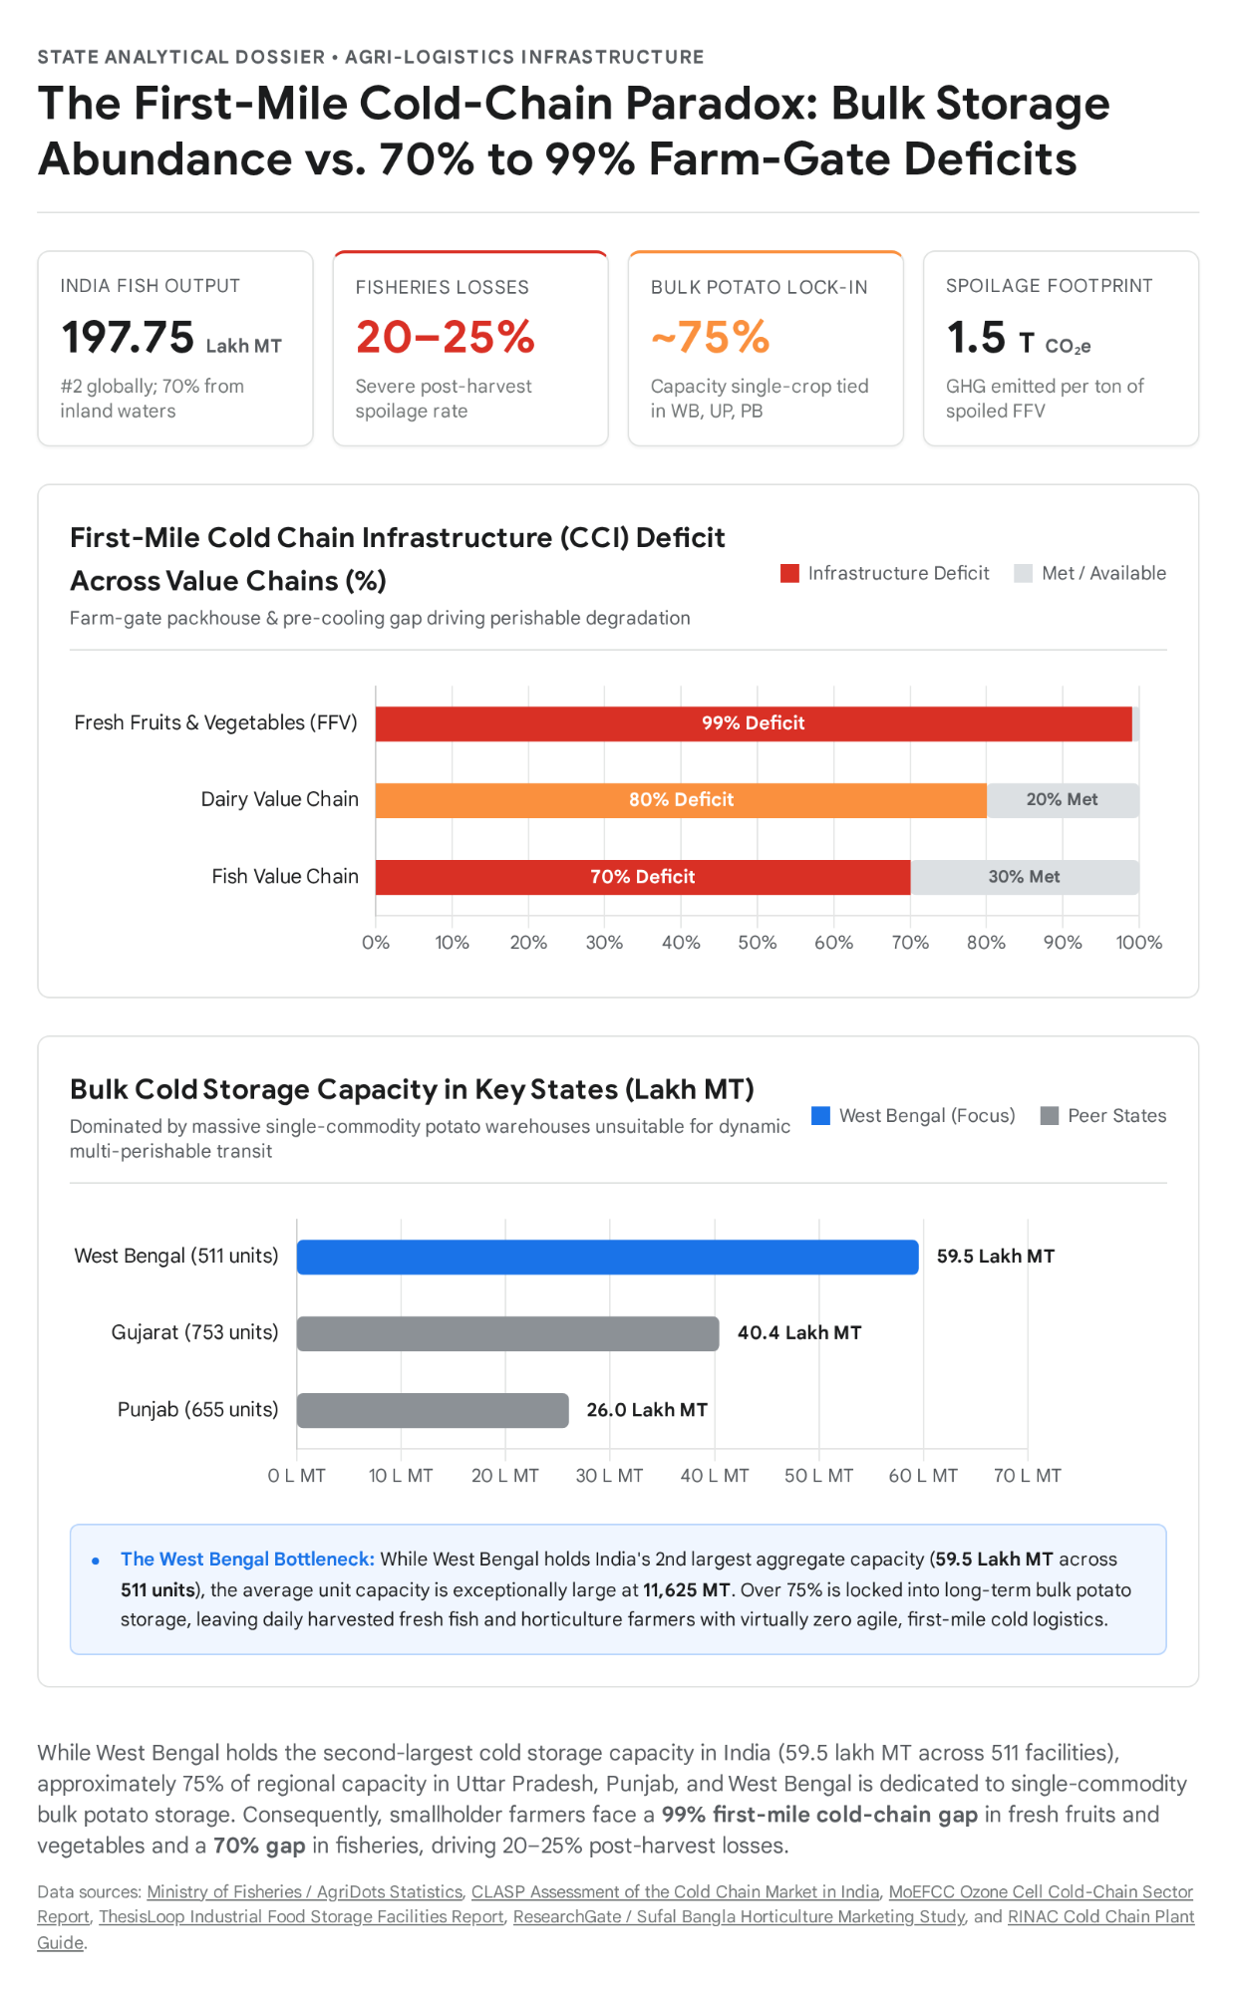

The Cold Storage Distortion: Why 59.5 Lakh MT of Capacity Fails Fish and Vegetable Farmers

A critical analytical insight for the SFIC 2026 evaluation jury is understanding why West Bengal suffers acute perishable losses despite ranking second in India in total cold storage capacity at 59.5 lakh MT across 511 facilities. Approximately 60% of India's total cold storage capacity is concentrated in Uttar Pradesh and West Bengal, and roughly 75% of capacity across Uttar Pradesh, Punjab, and West Bengal consists of Type-1 single-commodity bulk potato storage. Because West Bengal and Bihar together produce 71.99% of India's potatoes, private cold storage investment in the region has historically skewed toward massive, single-temperature chambers averaging 11,625 MT per facility in West Bengal and 20,315 MT in Uttar Pradesh.
These giant stationary warehouses are structurally incompatible with fresh fish and daily green vegetables for three interconnected reasons. First, thermodynamic and cross-contamination constraints prevent co-storage: bulk potato stores operate as single-zone chambers designed for long-term seasonal holding, whereas fresh fish requires immediate 0’C to 2’C Chilling and multi-commodity vegetables require segregated temperature and relative humidity (RH%) zones with rapid daily turnover, Secondly, there is a near-total absence of first-mile pre-cooling and packhouse mobility: national cold-chain assessments reveal a 99% infrastructure gap at the first mile (between farmgate and aggregation) for fresh fruits and vegetables, alongside an 80% gap in dairy and a 70% gap in the fish value chain. As the National Centre for Cold-chain Development emphasizes, stationary storage is only one piece of the cold chain and is not a standalone solution; a true cold chain applies thermal technology across transport to buy time and temporarily extend the marketable life of perishables from harvest to consumer. Third, over 90% of India's cold chain logistics sector is fragmented and privately owned, lacking standardization and serving formal corporate food retail and biomedical or export processors while bypassing rural smallholders.

Granular Corridor Mechanics: How Perishables Are Lost Waiting for Transport

The Sundarbans, South and North 24 Parganas, and Purba Medinipur Fisheries Corridors
Across the 19 blocks of the Indian Sundarbans—spanning South 24 Parganas and North 24 Parganas—and coastal Purba Medinipur, aquaculture farmers (bheri and pond operators) and estuarine or marine fishers depend on primary landing and auction centers such as Canning (Port Canning on the Matla River), Kakdwip, Namkhana, Raidighi, Diamond Harbour, Frazerganj, Sagar, and Patharpratima in South 24 Parganas (which hosts 14 capture landing centers and 188 fishing villages); Nazat, Dhamakhali, Malancha, Sandeshkhali, and Hingalganj in North 24 Parganas; and Digha Mohana, Sankarpur, Petuaghat, and Ramnagar in Purba Medinipur. Empirical survey data from the IFAD/UN West Bengal Coastal Areas Development Project reveals severe first-mile transport deprivation at primary auction centers like Digha Mohana: 15% of fish consignments are carried by head-load on foot, 80% move by unrefrigerated tricycle van or bicycle, and only 5% travel in motorized 2-tonner Tata Ace vehicles, typically when five small retailers or producers manually pool their catch to share a single vehicle traveling 12 km to Ramnagar. For longer secondary transit to urban wholesale hubs like the Howrah Fish Market or Kolkata processing zones, fish is packed crudely with crushed block ice into open or tarpaulin-covered 2-ton to 4-ton pickup trucks, specifically Tata
Also In riverine blocks such as Gosaba, Kultali, Basanti, and Hingalganj, producers must first cross tidal estuaries by boat to mainland hats, such as Dhakir Mukh in Kultali, or primary landing centers. Because an individual fish producer (Jeuni) or mud-crab collector cannot fill a 2-ton pickup truck alone, their catch sits on concrete auction floors or in bamboo baskets waiting for consolidation. During this delay, rapid enzymatic and bacterial spoilage degrades gill color and flesh firmness, forcing the producer to sell immediately at depressed prices through a four-tier intermediary chain: Aratdars, who charge a 5% to 7% auction commission from the producer; Paikars, who buy at primary landing auctions to resell at secondary urban markets in Kolkata and Howrah; and Chalandars, who supply processing units in Kolkata via commission agents. Empirical value chain analysis confirms that removing just one or two of these intermediary tiers via direct transport linkage yields an immediate 5% to 10% price realization gain for the farmer, even before accounting for the recovery of the 20% to 25% physical and quality post-harvest loss.

The Nadia, North and South 24 Parganas, and Bardhaman Horticulture Corridors

In intensive vegetable-producing districts such as Nadia—spanning wholesale and rural aggregation nodes in Chakdaha's Singher Hat Rail Bazar, Ranaghat, Krishnanagar, Bethuadahari, Majdia, Bagula, Barnia, Santipur, Nabadwip, and Kalyani—as well as Baruipur in South 24 Parganas and Bardhaman, smallholders harvest highly perishable crops including brinjal (eggplant), bitter gourd, green chilli, tomato, and pumpkin. Farmers and rural wholesalers transport produce via unrefrigerated road trucks or overnight suburban local trains into Sealdah's Koley Market in Kolkata, a 24/7 wholesale vegetable hub spanning over 5 acres that processes more than 1,000 tonnes of cargo daily, with peak truck unloading occurring between 2:00 AM and 7:00 AM. Other consignments travel on long-haul ambient trucks from Nadia to Siliguri and Forbesganj in Bihar.

While the Government of West Bengal launched Sufal Bangla—which publishes daily procurement and consumer prices for over 100 commodities, supports FPO-run static and mobile retail stores, and mobilizes 61 supply chain vehicles—and integrated 17 regulated mandis (2.9% of India's 585 enlisted mandis) into e-NAM, smallholders located 10 to 30 km away from collection hubs still bear the burden of first-mile transport, grading, and minimum supply consistency. Waiting at rural roadgates or railway platforms in 50-kg bags between afternoon harvest and early-morning wholesale windows triggers severe respiration, heat buildup, moisture loss, bruising from multiple handling, and fungal rot. Furthermore, each tonne of spoiled fruits and vegetables decomposes into approximately 1.5 tonnes of CO2 equivalent (CO2) in greenhouse gases, compounding rural economic loss with environmental damage.

Supply Chain Corridor | Primary Origin Nodes (West Bengal) | Terminal Wholesale / Retail Hubs | Dominant Current Transit Mode | Core Vulnerability & Value Loss Mechanism
Coastal & Estuarine Fisheries | Canning, Kakdwip, Namkhana, Raidighi, Frazerganj, Diamond Harbour (S. 24 Pgs); Nazat, Dhamakhali (N. 24 Pgs); Digha Mohana, Sankarpur, Petuaghat (Purba Medinipur) | Howrah Fish Market, Kolkata Secondary Markets, Chakberia / Kolkata Export Processing Units | 80% tricycle van/bicycle, 15% head-load, 5% shared Tata Ace (2T); secondary leg via iced 107/207/407 trucks | 3–6 hr wait for truck consolidation; rapid ice melt; 20–25% post-harvest loss; 5–7% Aratdar fee + Paikar/Chalandar margins.
Inland Pond Aquaculture | Farm & community ponds in East Midnapore, North 24 Parganas, Kharagpur, Hooghly, Moyna | Local district markets (e.g., Kharagpur's 13 markets), Howrah, Siliguri, and Bihar deficit markets | Open pick-up vans, cycle vans, and uninsulated drums | High feed cost (60–65% OPEX; ₹52–84/kg production cost) eroded by mortality/spoilage during multi-stop ambient transit.
Peri-Urban & Rural Horticulture | Nadia (Chakdaha, Ranaghat, Krishnanagar, Majdia, Bethuadahari), Baruipur (S. 24 Pgs), Bardhaman | Sealdah Koley Market (1,000+ MT/day), Mechhua Fruit Market, Sufal Bangla Hubs, Siliguri, Forbesganj (Bihar) | Overnight Sealdah local trains, open LCVs, cycle rickshaws, manual Palladar head-loads | High respiration heat in 50 kg bags; waiting from afternoon harvest until 2:00–7:00 AM Koley Market window; 1.5t CO2 /t rot.

